Exeption Handling Assignment -4

1.

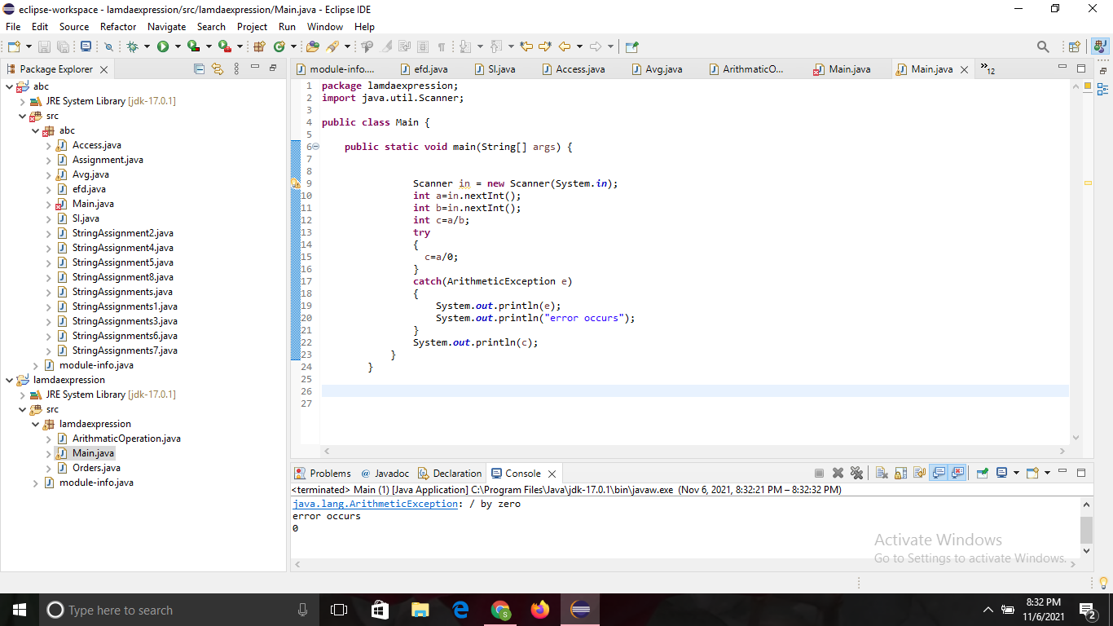

2.

**import** java.util.Scanner;

**public** **class** UnsupportedOperationException {

**public** **static** **void** main(String[] args) {

**try** {

Scanner input = **new** Scanner (System.***in***);

System.***out***.print("Input the first number:");

**int** a = input.nextInt();

System.***out***.print("Input the second number:");

**int** b = input.nextInt();

**float** d = (a/b);

System.***out***.println("result="+d);

}

**catch**(UnsupportedOperationException e)

{

System.***out***.println("Unsupported Operation Exception");

}

}

}

3.(a)

**package** lamdaexpression.Assignments;

**import** java.util.Scanner;

**class** InsufficientBalanceException **extends** Exception

{

**public** **void** InsufficientBalanceException(String msg)

{

}

}

**public** **class** Saving {

**long** id=1285;

**double** balance=2000;

**double** deposit;

**public** **void** InsufficientBalanceException(**double** withdraw) **throws** InsufficientBalanceException {

{

**if** ((withdraw > 2000) || (balance == 0)) {

**throw** **new** InsufficientBalanceException();

} **else** {

System.***out***.println("Amount withdrawn =");

System.***out***.print(withdraw);

}

}

}

**public** **static** **void** main(String[] args)

{

Scanner in = **new** Scanner(System.***in***);

**long** id=1285;

**double** balance=2000;

**double** deposit;

Saving on = **new** Saving();

**double** withdraw=in.nextDouble();

**try**

{

on.InsufficientBalanceException(withdraw);

}

**catch**(InsufficientBalanceException e)

{

System.***out***.println(e);

}

}

}

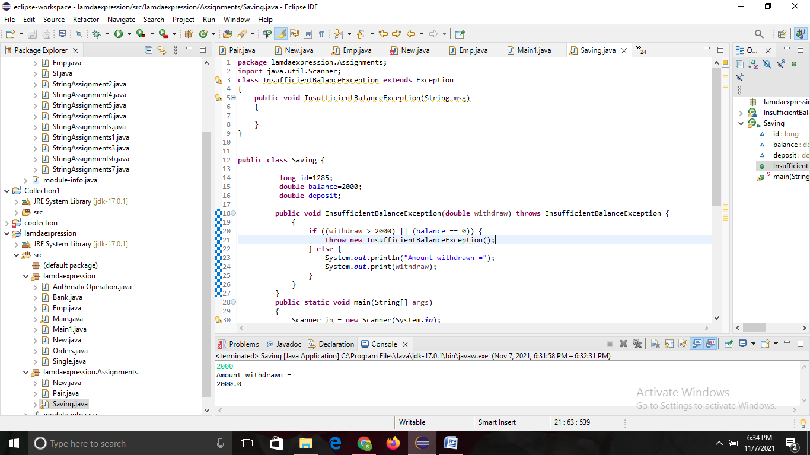

3.(b)

**package** lamdaexpression.Assignments;

**import** java.util.*;

**import** java.lang.*;

**class** IllegalBankTransactionException **extends** Exception

{

**public** **void** IllegalBankTransactionexception()

{

}

}

**public** **class** Bank {

**public** **void** IllegalBankTransactionException(**double** withdraw) **throws** IllegalBankTransactionException{

**if**(withdraw<0)

{

**throw** **new** IllegalBankTransactionException();

}

**else**

{

System.***out***.println("amount withdrawn ="+withdraw);

}

}

**public** **static** **void** main(String[] args)

{

**long** id=5784;

**double** balance=2000;

**double** deposit;

System.***out***.println("Enter the amount to be withdrawn = ");

Scanner in = **new** Scanner(System.***in***);

**double** withdraw = in.nextDouble();

Bank on = **new** Bank();

**try**

{

on.IllegalBankTransactionException(withdraw);

}

**catch**(IllegalBankTransactionException e)

{

System.***out***.println("Error occured");

}

}

}

